Stationery Store Inventory System

Project Plan

**Table of Contents**

**1.0 Project Overview** **3**

**2.0 Project Vision / Mission** **3**

**3.0 Project Description** **4**

**4.0 Project Objectives** **4**

**5.0 Project Team Structure** **5**

**6.0 Roles and Responsibilities** **5**

**7.0 Project Status Reporting** **7**

**9.0 Project Risk Management** **8**

**10.0 Project Deliverables / Milestones** **9**

# 

# **1.0 Project Overview**

Background:

The stationery inventory store is a department of Logic University, which is located at the basement of the main administration building. The store maintains an inventory of stationery commonly (90 types of stationery) used by all the departments in the University.

The description and stationery codes are recorded in stationery catalogues which are distributed to all departments. Currently all inventory records in the stationery store are maintained manually.

Departments use a physical copy of a Requisition Form to order stationery before seeking the approval by their department heads. This form should reach the Stationery Store by Wednesday and the disbursement is done the following Monday.

Key Areas of Concern and Pain Points:

* Departments are double charged for items due to re-ordering if there are no stocks
* Departments do not get the full quantity of stationery ordered as stocks are low
* Department Head cannot appoint a stand-in for approval if he isn’t in office/on leave
* Store Clerks have to manually go through stock during re-ordering, disbursement
* Store Clerks have to sometimes deal with last minute collection point changes
* Store Clerks follow specified re-order levels which might not be enough, no visibility on consumption rates of departments
* Store Manager is unable to view monthly reports of amount of stationery used for each department over designated time
* Store Supervisors and Managers are not notified quickly so they can approve the POs which also contributes to stock delay

# **2.0 Project Vision / Mission**

Project Vision: Meet the changing needs of the clients.

Project Mission: To reduce the amount of laborious work that had to be done in Logic University Stationery Store.

The system aims to bring about the following benefits, such as reducing the amount of manual work needed and to increase the efficiency in which stationery is disbursed to the University Departments. In turn, this will reduce the workload of stationery store staff even while ensuring that the Departments’ stationery requirements are adequately met. The system also aims to improve communication between the users of the system, by providing a series of notifications that are pushed to different respective users to prompt them for any action required.

# **3.0 Project Description**

The proposed system will be an online system where inventory management and requisition can be carried out.

The project is intended to be completed on the 20th of August 2019.

# **4.0 Project Objectives**

Goals:

1. Allow University staff to order stationery quickly, instead of going through a lengthy process
2. Reduce the conflicts between Departments and Stationery Inventory where items are double charged
3. Allow Department Heads to still be able to delegate approval roles to employees when he is not available, which will reduce bottlenecks at approval stages
4. Smoothen inventory control and management by reducing turnaround time for approvals and ordering

Automation:

1. Allowing department employees to order stationery in the system will remove the requirement to head down to the stationery store to pass their Requisition Forms. This will save time and increase productivity.
2. With the amount of transactions in and out of the stationery store, we hope to capture the data and translate them into an exportable, editable document. The store users can have a comprehensive, comparative analysis of the trends for the past few months so that they can make an assessment of what categories and departments are performing in relation to the purchase value.
3. As all the forms are hard copy now, there is no push notification that alerts the next user to follow-up on their next task (eg approval/incoming orders etc). With the implementation of the system to convert these physical forms into digitized copies, the system will enable push notifications that are automatically sent to the email inboxes and reduce waiting time.
4. The approval of the adjustment vouchers by either the supervisor or the manager will be determined and sent to the respective personnel automatically by the system instead of the current long and arduous process.

# **5.0 Project Team Structure**

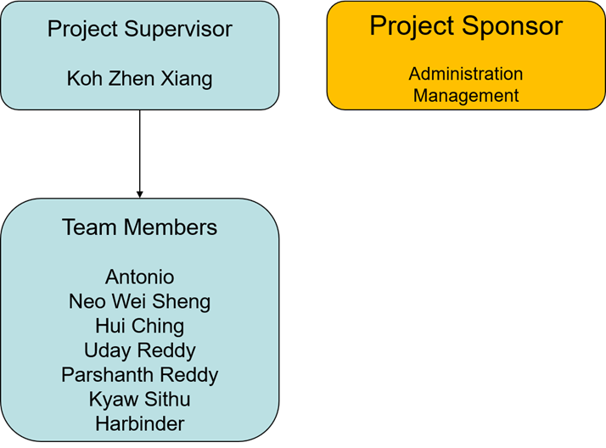

# **6.0 Roles and Responsibilities**

|  |  |
| --- | --- |
| **Members** | **Roles and Responsibilities** |
| Zhen Xiang | Develop Store side application in the Stationery Inventory System |
| Antonio | Develop Store side application in the Stationery Inventory System  To execute tests based on existing data set.The tester who raised the incident must follow up to verify and close the defect upon resolution. When it is not closed, System/Data Owners are to verify and close the defect. |
| Uday | Develop Store side application in the Stationery Inventory System.  To conduct diagnosis and rectification of errors detected |
| Prashanth | Develop Store side application in the Stationery Inventory System  To setup testing environment and ensure the necessary hardware, equipment, software installation for data migration UAT |
| Hui Ching | Develop Department side application in the Stationery Inventory System  To provide technical and operational direction  To track and report resolution progress |
| Wei Sheng | Develop Department side application in the Stationery Inventory System |
| Kyaw Sithu | Develop Department side application in the Stationery Inventory System |
| Harbinder | Develop Department side application in the Stationery Inventory System  To load all the relevant application programs to the testing environment  To control the release of the most up-to-date and correct data for testing |
| Client Project Sponsor | To review the test results  To verify if the all reported defect(s) have been rectified |

# 

# **7.0 Project Status Reporting**

To monitor and control progress against the project plan, the following methods will be used:

Each week, project team members will record the time (in hours) they have spent on each project subtask on a weekly reporting system; Progress will be measured against the project baseline.

A project progress report will be maintained throughout the project to record all significant events associated with the project, such as the issue of deliverables and decisions made by the team. A project progress report will be submitted which will summarise the project progress, itemise milestones that have been obtained, highlight problems such as milestones which are not expected to be attained on their planned dates, and plans for the next period.

Issues, risks and scope management will be managed and monitored following the described procedures below and their review status will be updated and discussed.

**8.0 Project Issue Management**

Project-related issues will be tracked, prioritized, resolved and communicated with Client.

Document: Project Issue Register YYYYMMDD.xls

Document Owner: Project Manager

Exchange Frequency: Bi-weekly

Template:

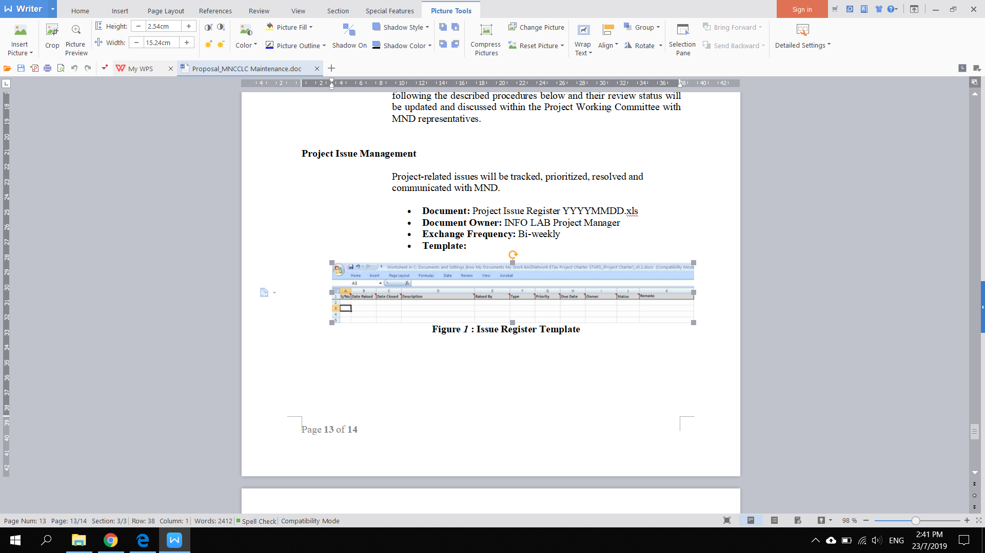

# 

# **9.0 Project Risk Management**

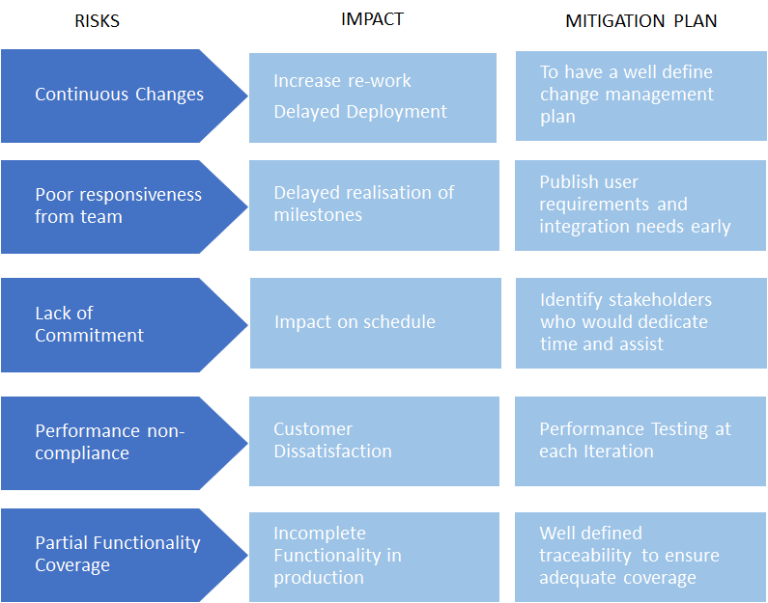

# 

# **10.0 Project Deliverables / Milestones**

|  |  |
| --- | --- |
| **Deliverables** | **Due Dates** |
| Project Plan | 26 July 2019 |
| UI Prototype   * Department’s UI * Store’s UI | 24 July 2019  25 July 2019 |
| User Requirement Specification Document | 29 July 2019 |
| Database Design (ER Diagram) | 01 August 2019 |
| Source Codes | 20 August 2019 |
| System User Guide | 16 August 2019 |
| UAT Test Plans | 16 August 2019 |
| Conduct UAT | 19 August 2019 |
| Weekly Project Status Reports   * Weekly Project Status 1 * Weekly Project Status 2 * Weekly Project Status 3 | 26 July 2019  02 August 2019  08 August 2019 |